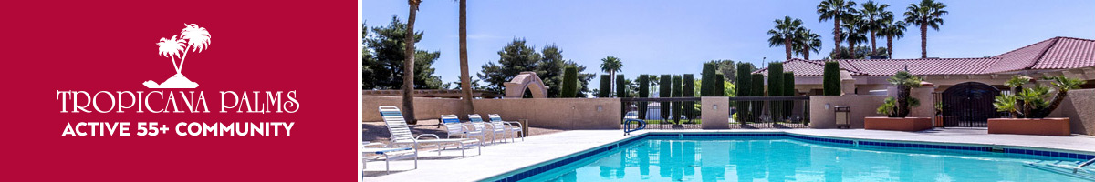

**6420 E. Tropicana Ave. * Las Vegas, NV 89122**

**Clubhouse #2**

**‘Meet the Local Authors’**

**Saturday, July 22nd, 2023 - 1.00 p.m. – 3.00 p.m.**

**Historical Inspirational**

**Fiction Poetry Memoir**



**Darlien Breeze Leslie Cain Diana Eden**

**Murder**

**Mystery** **Paranormal**  **Adventure**

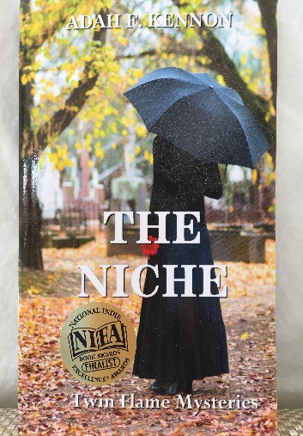 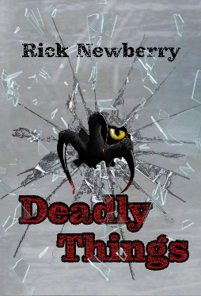 

**Adah Kennon Rick Newberry Fred Rayworth**